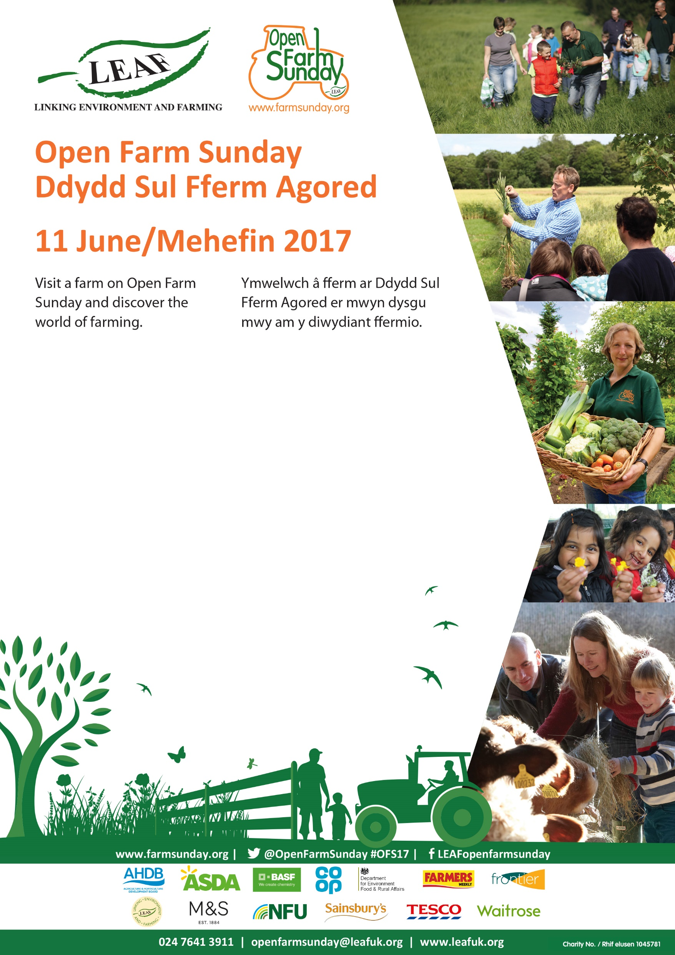

*(please edit)*

* Farm walks at 11:30am, 1pm and 2pm
* Demonstrations
* Come and meet our animals

Meet Farmer JohnXX and join us to discover the world of farming

**11am** to **3pm** *(please edit)*

**XX Farm Name** *(please edit)*xx Road, xx Village, xx County, xx Postcode