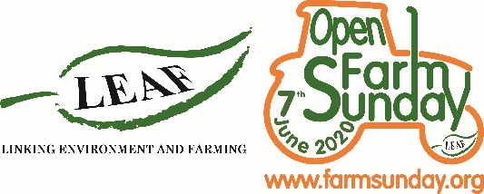
Support and Promote Social Media Posts
TWITTER (AND FACEBOOK)
Theme | Content | Text for post | Link | Channel
General | graphic | We love 💚@OpenFarmSunday – time to shout about what our wonderful industry delivers #LOFS20 #publicgoods  Shout out to everyone who’s signed up for this year’s @OpenFarmSunday – its an industry partnership. Together we’re telling the #GreatBritish farming story. https://farmsunday.org/open-my-farm  We can’t wait for this year’s @OpenFarmSunday on 20 September 💚😁– a day for the whole farming industry to be #proud of. Signed up yet?  BIG NEWS today we’re pledging our support for this year’s @OpenFarmSunday and calling on farmers to open up for the farming industry’s national open day on 20 September. Get involved at https://farmsunday.org/open-my-farm #LOFS20  Building stronger connections between farmers and the public involves the whole #AgIndustry. #LOFS20 #Partnerships 😁🤝 | https://farmsunday.org/open-my-farm  https://farmsunday.org/open-my-farm  https://farmsunday.org/open-my-farm  https://farmsunday.org/open-my-farm  https://farmsunday.org/open-my-farm | Twitter
Signpost to info pack and 1st time web page | Graphic  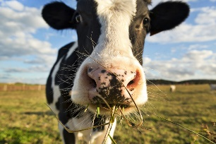 | Still pondering about whether to do @OpenFarmSunday this year? Take a look here https://farmsunday.org/open-my-farm/1st-time-host-farmer SO much support for #FirstTime host farmers #LOFS20😁🤝  Chewing over opening up this year for @OpenFarmSunday? You don’t need to – loads of amazing support from @OpenFarmSunday for #FirstTime host farmers #GoForIt #LOFS20 | https://farmsunday.org/open-my-farm/1st-time-host-farmer  https://farmsunday.org/open-my-farm/1st-time-host-farmer | Twitter
Case studies | Graphic | We love to hear stories from farmers who open up for @OpenFarmSunday #LOFS20 #Trailblazers #GameChangers 🤩 💚  LOOK 👀 here’s what farmers say about @OpenFarmSunday and why they love it #BritishFarming #BusinessBenefits #Communities #PublicGood #LOFS20  We just popped over to the @OpenFarmSunday page and were blown away by all the stories from farmers who are standing up for #BritishFarming by opening their farms for @OpenFarmSunday #LOFS20 | https://farmsunday.org/open-my-farm/case-studies  https://farmsunday.org/open-my-farm/case-studies  https://farmsunday.org/open-my-farm/case-studies | Twitter
Call for past farmers to take part again as its our 15th anniversary year | Graphic | BIG NEWS – we’re celebrating 15 wonderful years of @OpenFarmSunday the farming inudstry’s annual open day #LOFS20 – what better year to take part 😁🤝📢🎉  Time to get excited! It’s @OpenFarmSunday 15th birthday! Swing open those gates and join in the celebrations #LOFS20 🎉🎉  🤝Strengthening community relations  🤑Boosting sales  🚜Promoting #British Farming  😁Building better consumer engagement  🎉 Celebrating 15years of #LOFS  Just some of the reasons why we’re supporting this year’s @OpenFarmSunday | https://farmsunday.org/open-my-farm  https://farmsunday.org/open-my-farm  https://farmsunday.org/open-my-farm | Twitter

