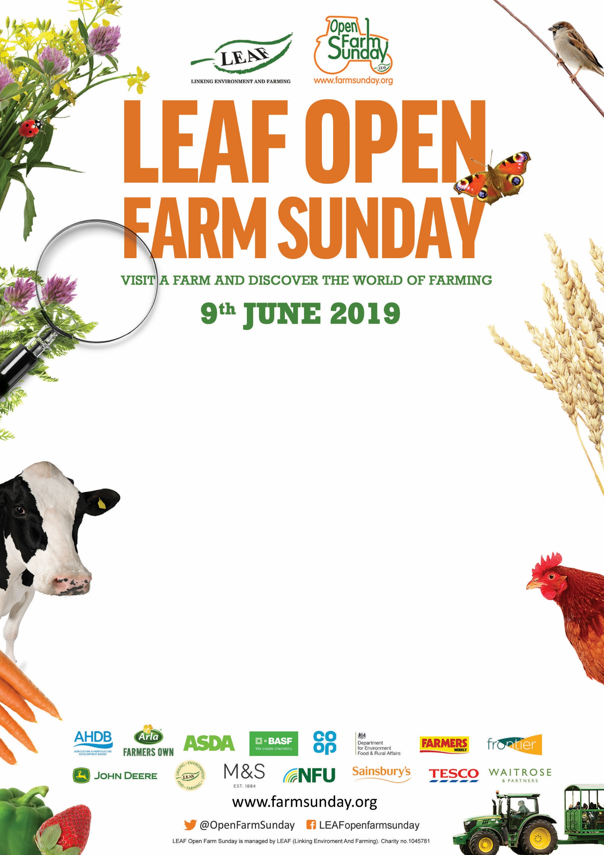

*Here is some suggested text for you to edit, to create your farm’s own event poster*

Come and join us at **Your Farm’s Name**Road, Village, County, Postcode

**11am** to **3pm**

*Tell your visitors what will be taking place at your event ……*

Eg. There will be guided farm walks at 11:30am and 2pm. Activities and demonstrations. Refreshments available to buy. Bring your own picnic.

Finally, add your farm’s contact details for the visitors should they have any questions.