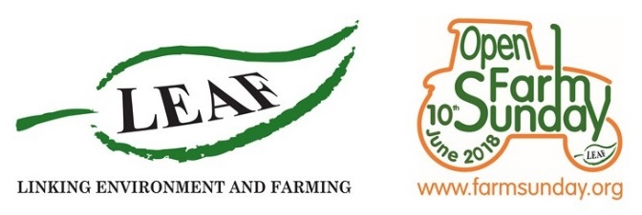

PRESS RELEASE
Visit INSERT NAME OF FARM on LEAF Open Farm Sunday (10th June 2018)
Farming’s annual open day
This LEAF Open Farm Sunday (10th June) make a date to visit INSERT NAME OF FARM.
LEAF Open Farm Sunday is The Great British Farm Day and offers a unique chance to see what happens beyond the farm gate and show your support for British farming. Hundreds of farms across the country will open their gates to welcome the public onto their farm to experience the magic of farming at first hand. Put a visit to INSERT NAME OF FARM on Sunday 10th June in your diary now!
This is your opportunity to speak with (eg. Farmer Jake and his team; you couple include details of other experts who will be with you on the day here, plus ) and find out all about what farming involves. Discover answers to the questions you’ve always wanted to ask … as well as some you’ve never even thought of!
On LEAF Open Farm Sunday you can learn more about (EDIT THE TEXT IN ITALICS BELOW ACCORDING TO WHAT YOUR EVENT WILL OFFER AND INSERT DETAILS ON ANY EXTRA ACTIVITIES ON OFFER – (This example is based on a mixed farm) See how the bread and cereal you enjoy at the breakfast table every morning is grown, learn why worms are so important for the soil on my farm and why we need bees and other pollinators to help us grow our potatoes/ fruit. On the day you can also find out how we look after and care for our cows/pigs, as well as the wonderful wildlife that lives on xx farm too.
INSERT A PICTURE OF YOU/YOUR FARM HERE.

BE SURE TO ATTACH 1 OR 2 IMAGE WHEN YOU SEND THIS OUT. - MAGAZINES AND NEWSPAPERS WILL NEED THESE TO PRINT.
Throughout the day there will be guided tours around the farm – which are a perfect way to discover all about British farming for yourself.
Come and get up close to the machinery we use every day and enjoy a tractor and trailer ride around the farm. See how science is used (provide an example here) and learn about how we use the latest technology to farm sustainably. And of course, take the opportunity to speak with the team / family / colleagues throughout the day to learn all about the world of farming.
As well as producing nutritious food, farmers also grow crops for medicines and clothes, as well as crops used for fuel and building homes. Together farmers care for over 70% of the British countryside, manage vital resources like water and soil, maintain miles of footpaths and hedgerows and provide homes for wildlife.
INSERT YOUR NAME HERE said; ‘WRITE A FEW WORDS ABOUT WHY YOU ARE EXCITED TO TAKE PART IN OPEN FARM SUNDAY AND WHAT YOU HOPE VISITORS WILL GET OUT OF THE DAY HERE’.
Annabel Shackleton, LEAF Open Farm Sunday Manager said: “From the wheat for our bread and cereals, and the potatoes and pork for our sausage and mash, through to crops for fuel, clothes and even cosmetics, it all begins on a farm. Farmers play a vital part in our daily lives and LEAF Open Farm Sunday is your chance to be part of The Great British Farm Day and show your support for British farmers and farming.”
To find out more about INSERT NAME OF FARM HERE and LEAF Open Farm Sunday visit INSERT FARM WEB ADDRESS HERE and www.farmsunday.org. LEAF Open Farm Sunday is managed by LEAF (Linking Environment And Farming), the leading organisation delivering more sustainable food and farming.
-Ends-
You can find out more about LEAF Open Farm Sunday at www.farmsunday.org and for further information contact:

INSERT YOUR CONTACT TELEPHONE NUMBER AND E-MAIL ADDRESS HERE

Editor’s note:
- LEAF Open Farm Sunday is managed by LEAF (Linking Environment And Farming). LEAF is the leading organisation delivering more sustainable food and farming. It works with farmers, the food industry, scientists and consumers to inspire and enable sustainable farming that is prosperous, enriches the environment and engages local communities. LEAF has organised Open Farm Sunday since it began in 2006. (LEAF is a registered charity no: 1045781)
- Sponsors of LEAF Open Farm Sunday 2018 are: Arla Foods, Asda, BASF plc, Co-op, Defra, Farmers Weekly, Frontier Agriculture, John Deere, LEAF Marque, Marks and Spencer, The National Farmers’ Union, Sainsbury’s, Tesco, Waitrose and the Agriculture and Horticulture Development Board.
- To keep up to date on Twitter follow @OpenFarmSunday and @LEAF_Farming

